Installation steps

Getting Started

1. Open Visual Studio Community 2019
2. Clone repository: <https://github.com/TECHCareers-by-Manpower/capstone-project-codered.git>
3. Install packages:
   1. Microsoft.AspNetCore.Identity.EntityFrameworkCore
   2. Microsoft.AspNetCore.Identity.UI
   3. Microsoft.AspNetCore.Mvc.NewtonsoftJson
   4. Microsoft.AspNetCore.SpaServices.Extensions
   5. Microsoft.EntityFrameworkCore.Design
   6. Microsoft.EntityFrameworkCore.Sqlite
   7. Microsoft.EntityFrameworkCore.SqlServer
   8. Microsoft.EntityFrameworkCore.Tools
   9. Microsoft.VisualStudio.Web.CodeGeneration.Design
   10. Pomelo.EntityFrameworkCore.MySql

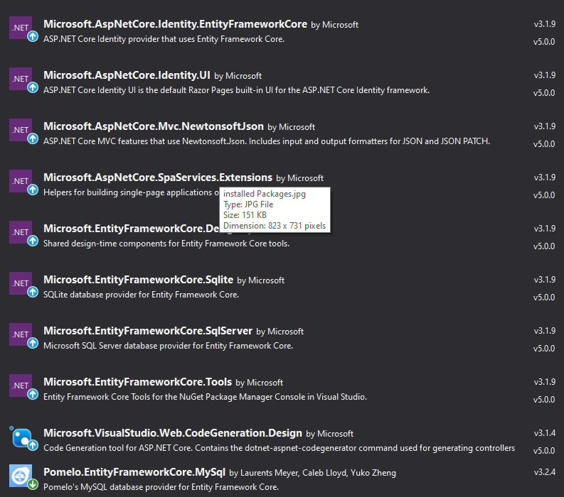

1. Run 2 commands to create migration and update database in this order:
   1. dotnet ef migrations add InitialMigration --context codeRed_Capstone.Models.CompanyContext
   2. dotnet ef database update --context codeRed_Capstone.Models.CompanyContext

Note: Copy past might not work sometimes. If so just type it manually.

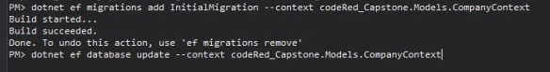

1. Make sure your XAMPP server up and running. If you don’t have XAMPP server installed, please see procedure below.
2. Run the program by clicking IIS Express button.
3. Register to get access.

How to use the App:

1. First time access - at the start HR would have to register and choose unique email address to be recognized by the app upon next login.
2. Once logged in HR staff would be able (if need so) change setting of the login system and apply 2 way authentication system.
3. Primary display will show a list of all employees with-in the company hierarchy.
4. This App will allow HR staff to Search this list by email address and by last name if needed. Search by Last name will take into consideration that more than 1 entity can exist with the same last name.
5. There will be a toggle checkbox as well which will allow to filter out all entities that are already laid off and delete them.
6. This list will also allow sorting my Last name in ascending order, Group By Departments, sort by Email address and sort by Hired Date in chronological order.
7. Each Entity will also have an email hyper link which allows to contact person by email.
8. Each Entity will have 3 action icons: Edit, Display and Delete.  
   a) Edit will allow to edit any field previously entered during creation of the entity and also add Fired Date to the entity id this person was laid off.  
   b) Display will allow to see all fields again and on to of that to see when this entry was last edited(timestamp). This Display page will also be used for search results and error messages if certain entity was not found.  
   c) Delete option will have a pop up message warning that "you are about to delete a person" and Delete page were HR staff can change their mind before final deletion.
9. Last feature that this table will have a user friendly layout of this table for the phone devices, because tables are hard to fit on the small screen, upon small screen detection by the media query. Table will be re-formatted in to block view design.
10. Finally there will be a logout button at the top right corner that allows HR staff to logout when editing or updating is done.

How to install XAMPP server

<https://blog.templatetoaster.com/install-xampp-on-windows/>

